4. Project Planning Phase
Project: Implement Client Script & UI Policy (ServiceNow)

Phase Objective
The work is organized into implementation steps. The video shows the project workspace, configuration screens, selected fields, and the sequence used to prepare the form before coding and testing.

Activities Covered
- Prepare the implementation sequence.
- Select the records and fields to configure.
- Move from the planned design toward actual configuration.

Screenshots from the Project Video
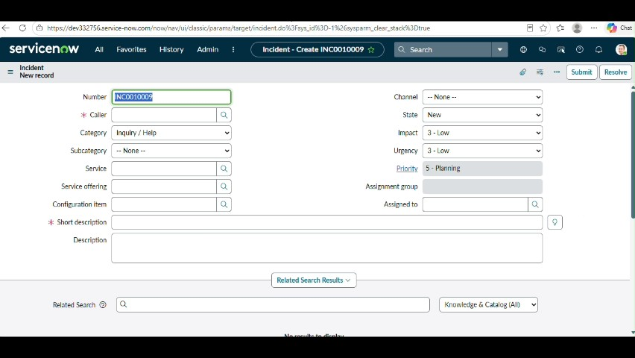
Figure 1: Project video screen at approximately 152 seconds.
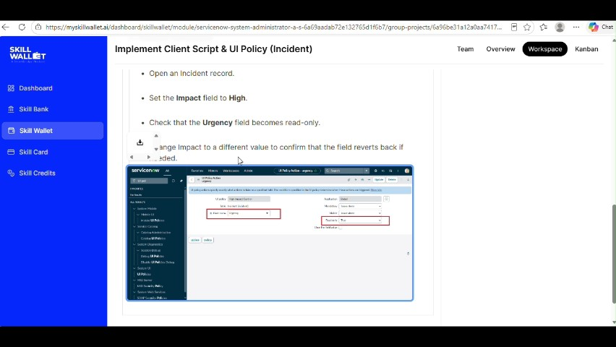
Figure 2: Project video screen at approximately 165 seconds.
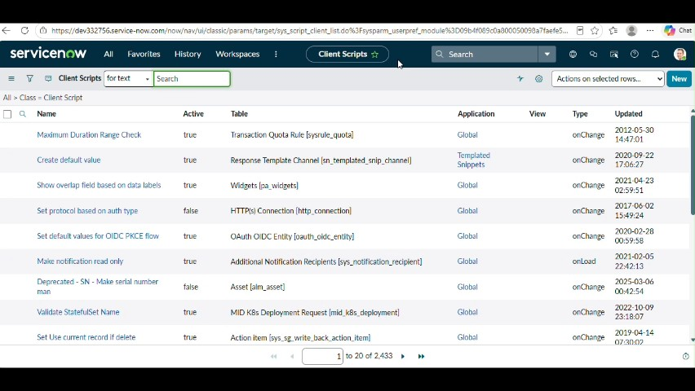
Figure 3: Project video screen at approximately 182 seconds.
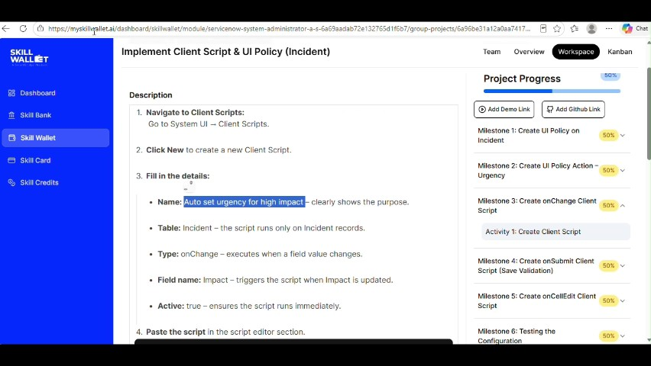
Figure 4: Project video screen at approximately 194 seconds.
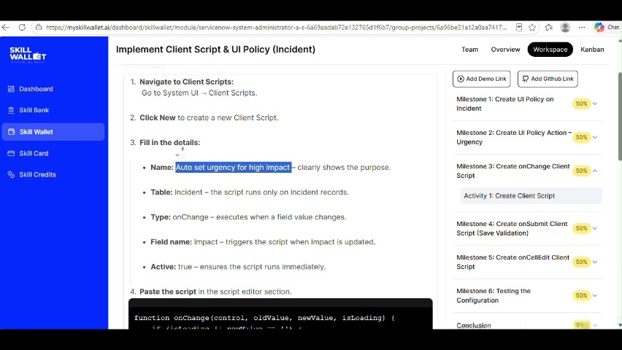
Figure 5: Project video screen at approximately 205 seconds.

Phase Outcome
The implementation work is organized into a clear sequence of configuration and verification steps.
Prepared from the supplied project demonstration video

